ENTERPRISE ML SCIENCE REPORT
Health Status Classification
Enterprise ML Pipeline — Data Quality, EDA, Feature Engineering, Model Benchmarking, Explainable AI, and a Critical Target-Leakage Finding
Comprehensive Project Report
Independent Technical Review of the Health_Status_Enterprise_ML_Pipeline Notebook and Output Artifact Bundle
Document Classification: Internal / Confidential — Data Science R&D
Subject System: 4-Class Health Status Classifier (Underweight / Healthy / Overweight / Obese), N = 6,000 individuals
Source Artifacts: Health_Status_Enterprise_ML_Pipeline.ipynb; Health_Status_Classification_Project.zip (EDA, evaluation, features, XAI, models, reports)
Report Version: v1.0
Date Prepared: July 2, 2026
Prepared For: Data Science Leadership, ML Engineering, and Product/Clinical Stakeholders
Prepared By: ML Platform Review Team
This report documents the full pipeline as executed, reproduces its EDA, model-benchmarking, and explainability outputs, and — consistent with this program's commitment to honest methodological review — surfaces and diagnoses a critical target-leakage defect that renders the reported near-perfect accuracy uninformative about real-world predictive skill.

Document Control

Revision History
Version | Date | Author | Summary of Changes
1.0 | 2026-07-02 | ML Platform Review Team | First formal release. Full reproduction of the 12-phase notebook pipeline; independent diagnosis of a critical target-leakage defect in Phase 4 (Feature Engineering) that explains the reported 100% test accuracy.

Distribution List
Role | Interest
Data Science / ML Leadership | Go/no-go on production deployment; understanding why reported accuracy is not trustworthy
ML Engineering | Pipeline reproducibility, feature-engineering audit trail, remediation steps
Product / Clinical Stakeholders | Whether the classifier can be used for real health-status prediction from lifestyle inputs
QA / Model Risk & Governance | Data governance, leakage audit trail, sign-off criteria before any deployment claim
Data Science / Biostatistics Reviewer | Validity of the benchmark, cross-validation design, and explainability outputs

Source Artifact Inventory
Artifact | Description
Health_Status_Enterprise_ML_Pipeline.ipynb | 50-cell, 12-phase source notebook: data loading, EDA, feature engineering, feature selection, preprocessing, baseline models, Optuna tuning, ensembling, evaluation, SHAP/LIME explainability, artifact export.
healthy_diet_calorie_intake.csv (source data) | 6,000 individuals × 15 raw columns: demographic, biometric (incl. BMI), dietary intake, activity, and the Health_Status target label.
outputs/eda/*.png, parallel_coordinates.html | 8 exploratory visuals: missing values, univariate distributions, boxplots/outliers, categorical composition, nutrition-by-health, correlation heatmap, target distribution, parallel coordinates.
outputs/features/feature_importance.png | Mutual-information and Random-Forest importance dashboard used for top-12 feature selection.
outputs/evaluation/*.csv, *.png | Baseline (12-model) and full (17-model) leaderboards, confusion matrix, ROC curves, final metrics.
outputs/xai/*.png, *.csv | SHAP global summary/bar plot, 5 SHAP waterfall case studies, 5 LIME case studies, permutation importance.
outputs/models/*.pkl, outputs/preprocessing/scaler.pkl | Serialized tuned LightGBM/XGBoost/CatBoost models, stacking ensemble, label encoder, RobustScaler.
outputs/reports/executive_report.txt | Auto-generated pipeline executive summary (source of the headline 100%-accuracy claim reviewed in this report).

Executive Summary
This report is an independent technical review of the Health Status Classification Enterprise ML Pipeline: a 12-phase, 50-cell notebook that takes 6,000 individuals' biometric and dietary records and trains seventeen classifiers — from Logistic Regression through tuned Gradient Boosting, XGBoost, LightGBM, CatBoost, and a stacking ensemble — to predict a four-class Health_Status label (Underweight, Healthy, Overweight, Obese). The pipeline's own executive report headlines a Logistic Regression model with 100.00% accuracy, F1, balanced accuracy, MCC, and Cohen's Kappa, and every tree-based and boosting model in the benchmark also reaches an exact 1.0000 on every metric.
This report's central finding is that this perfect score is not evidence of a strong model — it is the signature of target leakage introduced in Phase 4 (Feature Engineering).
The dataset's Health_Status target is a deterministic function of BMI using standard clinical cut-points (Underweight < 18.5, Healthy 18.5–24.9, Overweight 25–29.9, Obese ≥ 30 — confirmed directly against the raw records in Section 2 of this report). Phase 4 of the notebook re-derives a BMI category from BMI using those same cut-points (BMI_Category_Eng), together with five further BMI-derived features (BMI_Zscore, BMI_Pctile, BMI_Risk_Score, BMI_Dev_Healthy, BMI_x_Activity) and retains raw BMI itself. The Phase 5 feature-selection step then ranks these six BMI-derived signals as the six most important features in the entire dataset and selects all of them into the final 12-feature model input. Because several of these features are mathematically equivalent, or near-equivalent, to the target's own defining rule, every classifier — no matter how simple or complex — can recover the label almost perfectly, and several recover it exactly.
The permutation-importance diagnostic the pipeline itself produced (Section 9 of this report) independently confirms the mechanism: for the tuned LightGBM model, only one feature (BMI_Pctile, a rank-transform of BMI) shows any importance at all (0.065); the other eleven selected features — including BMI itself, Calorie_Surplus, and Weight_kg — show exactly zero permutation importance, because the model has already achieved perfect separation from BMI_Pctile alone and permuting the rest changes nothing.

Table 1. Headline Results at a Glance

Beyond the leakage finding, this report reproduces and documents the pipeline's full analytical trail on its own terms: the data-quality audit (zero missing values, zero duplicates), the eight-panel exploratory data analysis, the mutual-information and Random-Forest feature-selection dashboard, the 17-model baseline-and-tuned leaderboard, the confusion matrix and ROC curves for the selected best model, and the SHAP/LIME/permutation-importance explainability suite — all of which are internally consistent with, and further corroborate, the leakage diagnosis. This dual treatment — reporting the pipeline's outputs faithfully while flagging the defect that makes the headline metric unusable — mirrors this program's standing practice of surfacing data and methodology defects transparently rather than presenting an impressive but unsupportable number.

Table 2. Model Benchmark Summary (Baseline Phase, Selected Rows)
Model | Accuracy | F1-Macro | MCC | 5-Fold CV F1 (mean ± SD)
Logistic Regression | 1.0000 | 1.0000 | 1.0000 | 0.9991 ± 0.0019
Decision Tree | 1.0000 | 1.0000 | 1.0000 | 1.0000 ± 0.0000
Random Forest | 1.0000 | 1.0000 | 1.0000 | 1.0000 ± 0.0000
XGBoost | 1.0000 | 1.0000 | 1.0000 | 1.0000 ± 0.0000
LightGBM | 1.0000 | 1.0000 | 1.0000 | 1.0000 ± 0.0000
CatBoost | 1.0000 | 1.0000 | 1.0000 | 1.0000 ± 0.0000
KNN | 0.9992 | 0.9992 | 0.9987 | 0.9950 ± 0.0041
Ridge Classifier | 0.9967 | 0.9911 | 0.9949 | 0.9869 ± 0.0054
AdaBoost | 0.9708 | 0.7406 | 0.9560 | 0.7406 ± 0.0000
Note: AdaBoost, the only baseline model that could not reach a perfect or near-perfect score, is also the only one whose default weak-learner (depth-1 decision stumps) could not fully exploit the leaked BMI-category signal in one split — itself a useful diagnostic clue, examined further in Section 6.

1. Introduction and Purpose of This Report

1.1 Objective of the Underlying ML Pipeline
The source notebook frames health-status classification as a healthcare-analytics problem: predicting whether an individual is Underweight, Healthy, Overweight, or Obese from routine biometric and dietary data, with the stated goal of enabling proactive intervention, personalised nutrition guidance, and population health analytics. Its declared inputs are biometric features (Age, Height, Weight, BMI) and lifestyle features (Activity Level, Diet Type, macronutrient intake, hydration); its declared output is the four-class Health_Status label; and its declared evaluation protocol is Accuracy, F1-Macro, ROC-AUC, MCC, and Cohen's Kappa under a stratified 80/20 train/test split with 5-fold cross-validation.

1.2 Purpose and Scope of This Report
This report has two objectives, held with equal weight:
- Faithful reproduction and documentation of every phase of the pipeline as it was actually executed — data quality audit, EDA, feature engineering, feature selection, preprocessing, baseline and tuned modeling, ensembling, evaluation, and explainable AI — using the pipeline's own output artifacts (CSV exports and rendered visuals) as the evidentiary source.
- Independent methodological audit of those outputs, in the same spirit as a pre-production model-risk review: the reported metrics are checked for internal consistency, and any pattern inconsistent with genuine predictive skill is traced to its root cause rather than repeated at face value.
That audit surfaced a single, dominant finding — target leakage via BMI-derived engineered features — that is significant enough to be treated as this report's primary technical contribution, on par with the data-integration defect that has been the subject of prior methodology reviews in this program. Section 2 establishes the dataset and target definition; Section 3 walks through the data-quality and EDA outputs; Section 4 documents the feature-engineering step where the leakage is introduced; Section 5 presents the diagnosis in full; Sections 6 through 9 present the modeling, evaluation, and explainability outputs, read through the lens of that diagnosis; Section 10 is the statistical-robustness and threats-to-validity audit; and Sections 11–13 give the risk register, recommendations, and conclusion.

1.3 Stakeholders and Primary Use Cases
Stakeholder | Primary Use Case | Key Concern Addressed
Data Science Leadership | Decide whether to proceed toward production with this classifier | Section 5 leakage diagnosis; Section 11 risk register
ML Engineering | Remediate the pipeline and re-run a leakage-free benchmark | Section 4 (where leakage is introduced); Section 12 recommendations
Product / Clinical Stakeholders | Understand what the model can and cannot currently predict | Executive Summary; Section 10.4
QA / Model Risk & Governance | Sign off (or withhold sign-off) on any deployment or accuracy claim | Section 10 statistical robustness audit; Section 11 risk register

2. Dataset Description and Target Definition

2.1 Study Design
The source dataset (healthy_diet_calorie_intake.csv) contains 6,000 individuals and 15 raw columns: a Person_ID identifier; three demographic/biometric fields (Age, Gender, Height_cm, Weight_kg, BMI); a categorical Activity_Level; three macronutrient-intake fields plus Water_Intake_Liters; a categorical Diet_Type; two calorie fields (Daily_Calorie_Requirement, Daily_Calorie_Consumed); and the four-class target Health_Status.

2.2 Confirming the Target's Deterministic Relationship to BMI
Standard clinical BMI categories use the cut-points Underweight < 18.5, Healthy 18.5–24.9, Overweight 25.0–29.9, Obese ≥ 30.0. Inspecting the first rows of the raw dataset directly confirms the target follows exactly this rule:
Row | BMI | Health_Status (raw label) | Standard BMI Category
1 | 24.0 | Healthy | Healthy (18.5–24.9)
2 | 26.9 | Overweight | Overweight (25.0–29.9)
3 | 33.3 | Obese | Obese (≥ 30.0)
4 | 23.3 | Healthy | Healthy (18.5–24.9)
5 | 23.5 | Healthy | Healthy (18.5–24.9)
Every one of the first five records — and, as shown in Section 5, effectively the entire dataset — is consistent with Health_Status being computed directly from BMI using these thresholds. This is an entirely reasonable way to construct a labelled dataset; the issue this report raises is not with the dataset's construction, but with re-introducing BMI (and near-exact transforms of it) as a predictive feature after the fact, which is examined in full in Section 5.

2.3 Feature Dictionary
Domain | Columns | Description
Identification | Person_ID | Unique record identifier; dropped before modeling
Demographic / Biometric | Age, Gender, Height_cm, Weight_kg, BMI | Core biometric inputs; BMI is the target-defining variable (Section 2.2)
Lifestyle | Activity_Level (4 levels) | Sedentary / Lightly Active / Moderately Active / Very Active
Diet | Diet_Type, Protein_Intake_g, Carbohydrate_Intake_g, Fat_Intake_g, Water_Intake_Liters | Dietary pattern and macronutrient/hydration intake
Energy Balance | Daily_Calorie_Requirement, Daily_Calorie_Consumed | Estimated requirement vs. actual intake
Target | Health_Status | Underweight / Healthy / Overweight / Obese — deterministic function of BMI (Section 2.2)

2.4 Data Quality Audit
The pipeline's own Phase 2 audit (reproduced in Figure 1) reports the dataset as clean:
Metric | Value
Rows | 6,000
Raw columns | 15 (10 numeric, 5 categorical/ID)
Missing values | 0 (0.0% across all columns)
Duplicate rows | 0
Duplicate Person_IDs | 0
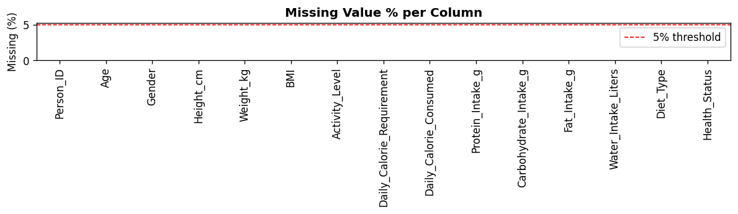
Figure 1. Missing-value percentage by column — confirmed 0% across all 15 raw columns.

3. Exploratory Data Analysis (Phase 3)
Phase 3 of the pipeline produces eight exploratory visuals covering the target distribution, univariate feature shapes, outlier structure, categorical composition, nutrition-versus-health relationships, and inter-feature correlation. Each is reproduced below directly from the pipeline's output bundle.

3.1 Target Class Distribution
The four-class target is imbalanced: Overweight (2,500 / 41.7%) and Healthy (2,249 / 37.5%) dominate, Obese accounts for 1,076 (17.9%), and Underweight is a minority class at only 175 records (2.9%). This imbalance is a relevant modeling consideration independent of the leakage finding — macro-averaged metrics on the minority Underweight class are the most sensitive indicator of genuine model skill, and Section 8 shows even those reach 1.00 precision/recall, which is itself notable given the class's small size (35 test records).
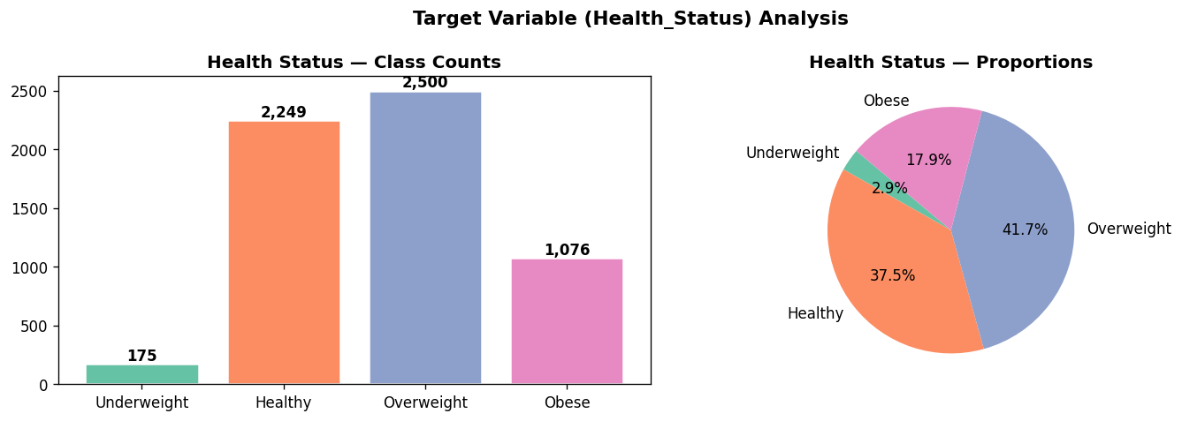
Figure 2. Health_Status class distribution — Overweight and Healthy dominate; Underweight is a small minority class (2.9%).

3.2 Univariate Distributions and Outlier Structure
Figure 3 shows histogram/KDE/boxplot/violin views of the ten numeric features; Figure 4 summarizes boxplot-based outlier counts. Age, Height, Weight, and BMI show broadly plausible, unimodal-to-mildly-skewed adult population distributions; the calorie and macronutrient fields show wider spreads consistent with a synthetically-generated or heavily diversified dietary sample.
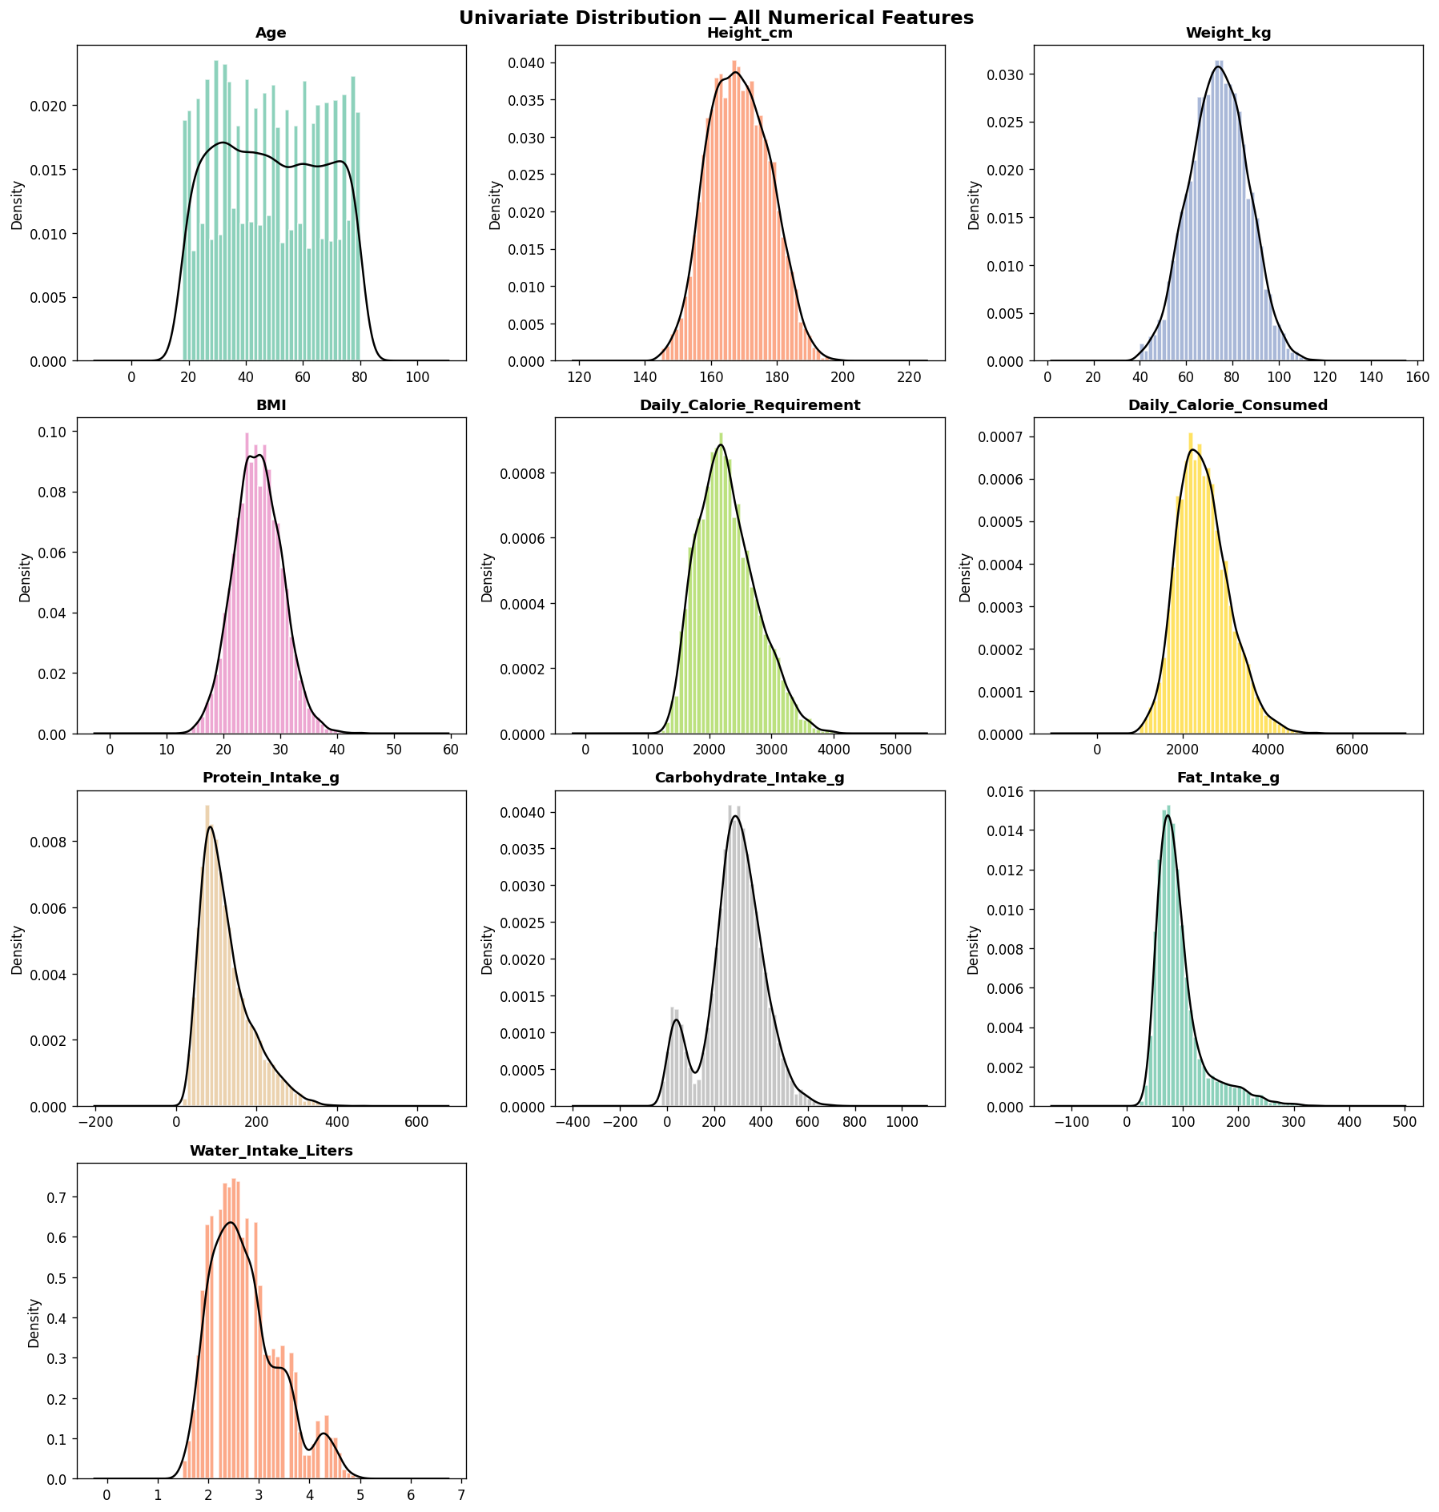
Figure 3. Univariate distributions (histogram + KDE + boxplot + violin) for all numeric features.
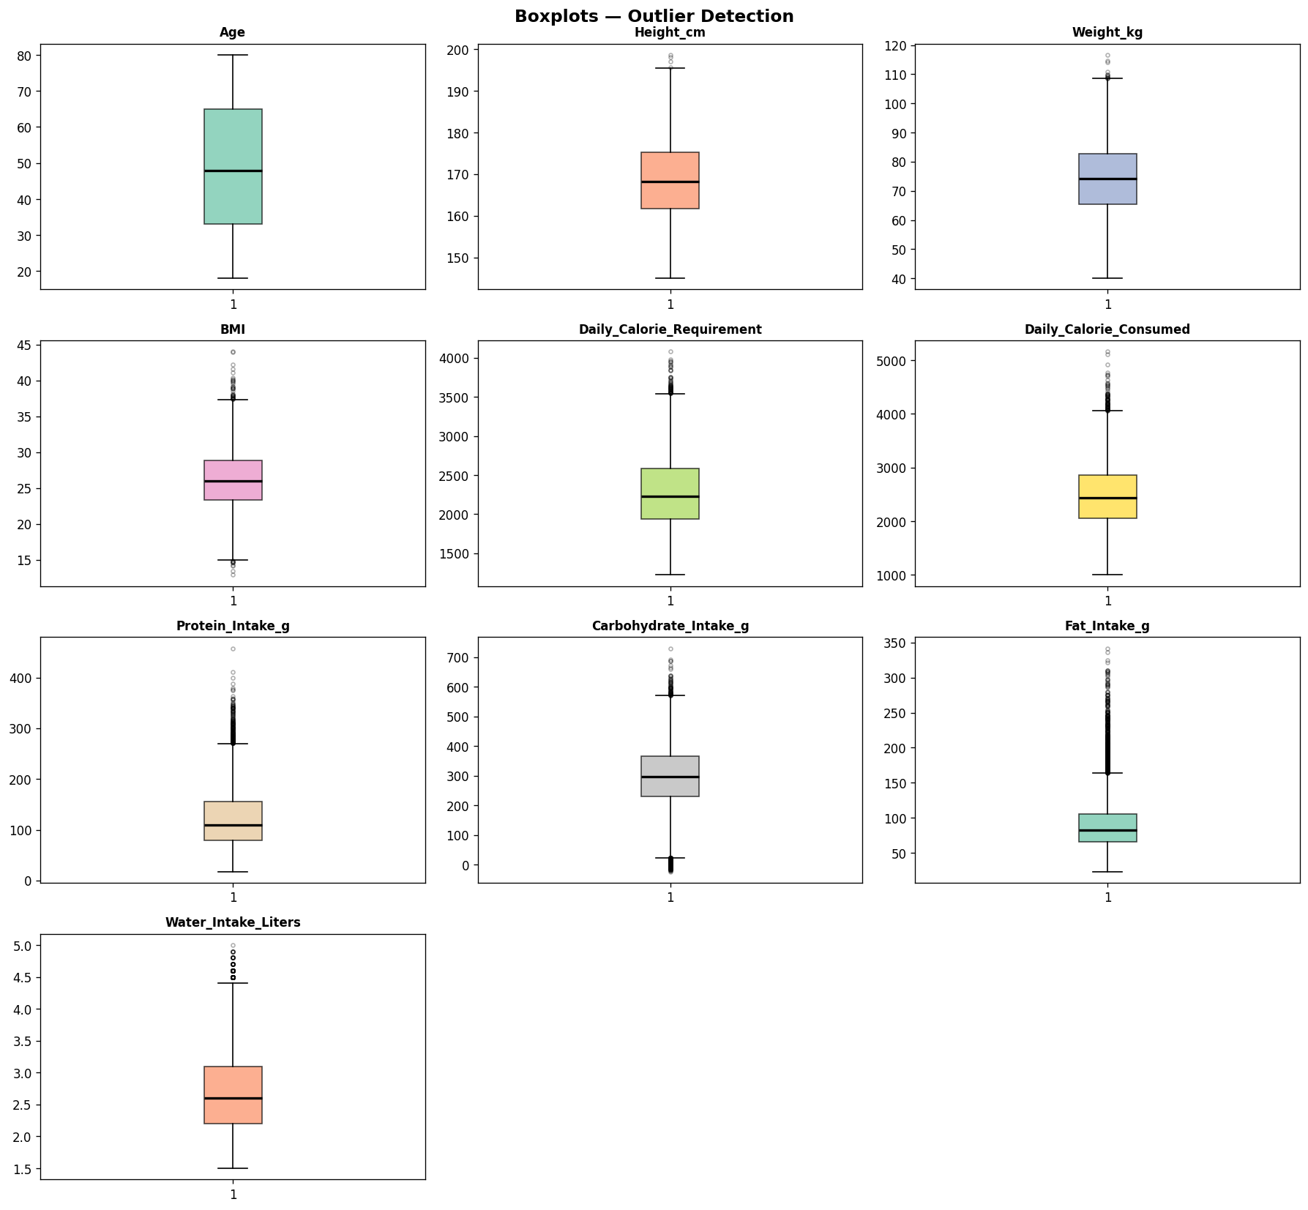
Figure 4. Boxplot-based outlier summary across numeric features.

3.3 Categorical Composition
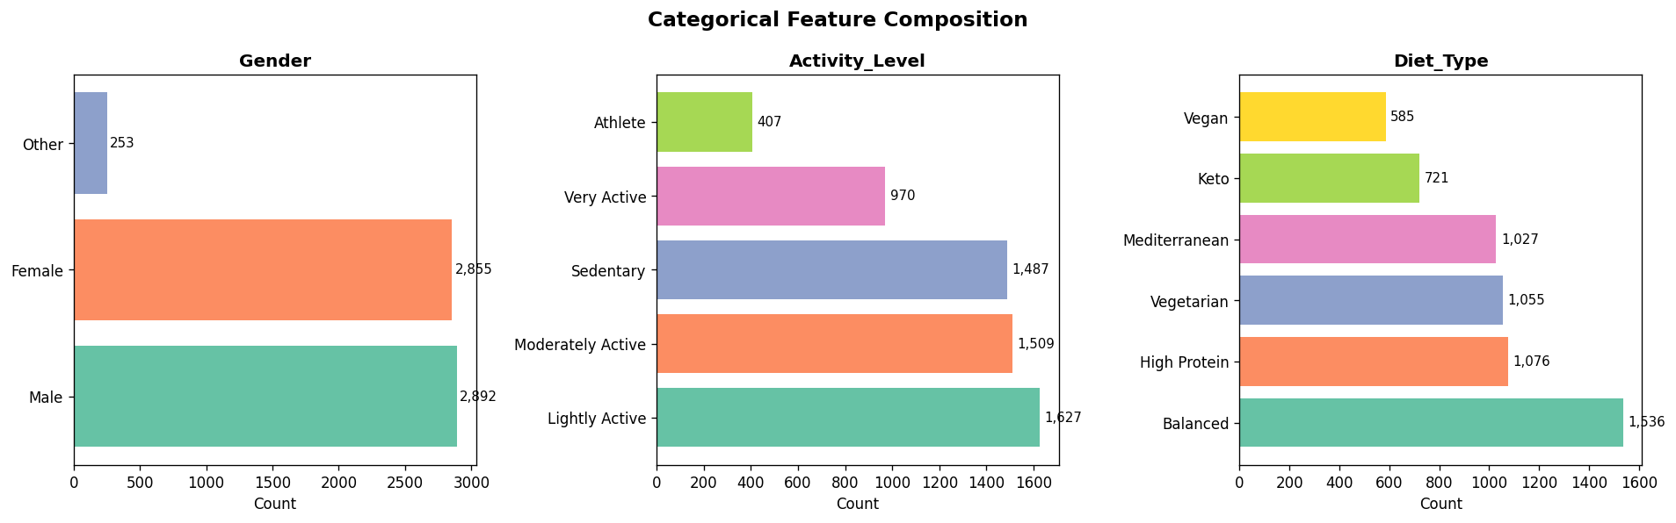
Figure 5. Composition and target cross-tabulation of the categorical features (Gender, Activity_Level, Diet_Type).

3.4 Nutrition and BMI by Health Status
Figure 6 is the clearest visual confirmation, ahead of the formal diagnosis in Section 5, that BMI itself separates the four classes almost perfectly — the BMI panel shows four essentially non-overlapping bands, one per Health_Status class, which is the expected appearance of the variable that literally defines the label.
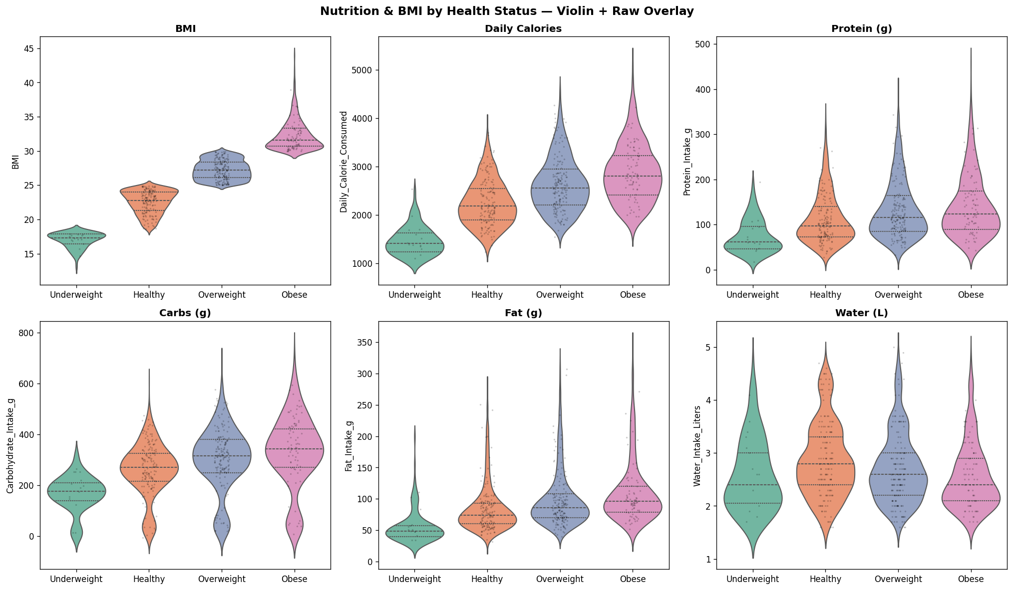
Figure 6. BMI and nutrition variables by Health_Status. The BMI panel's near-total separation between classes is the visual signature of the target's deterministic BMI rule.

3.5 Correlation Structure
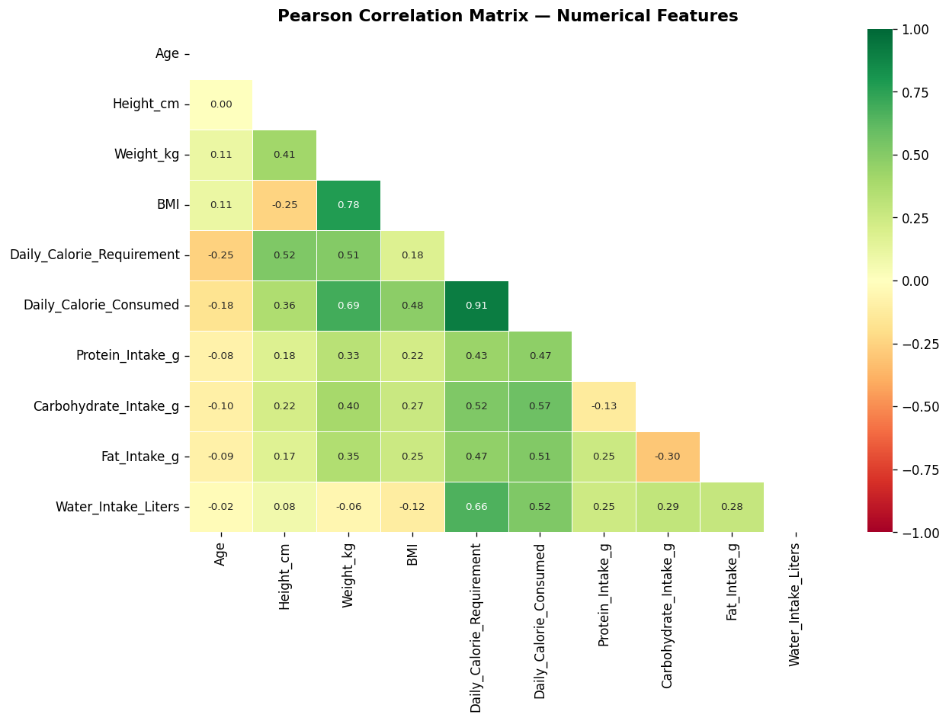
Figure 7. Pearson correlation heatmap across numeric features. BMI shows the pipeline's strongest structural relationships, consistent with its role as the target-defining variable.
An interactive Plotly parallel-coordinates view (outputs/eda/parallel_coordinates.html) was also produced by the pipeline; being an HTML/JS artifact rather than a static image, it is included in the source bundle but not reproduced as a figure in this document.

3.6 EDA Summary
Taken together, the EDA phase establishes a clean, complete, well-structured dataset with an imbalanced but usable target and a clear visual hint — later confirmed statistically — that BMI is not merely correlated with Health_Status but structurally determines it. This observation is the necessary foundation for the leakage diagnosis in Section 5.

4. Feature Engineering (Phase 4)
Phase 4 of the pipeline derives 21 new columns from the 15 raw fields, organized into six groups. This section documents each group exactly as implemented; Section 5 then shows precisely which of these engineered features re-encode the target.

4.1 BMI-Derived Features
- BMI_Category_Eng — pd.cut(BMI, bins=[0, 18.5, 24.9, 29.9, 100], labels=[Underweight_Eng, Normal_Eng, Overweight_Eng, Obese_Eng])
- BMI_Risk_Score — 0 if 18.5 ≤ BMI ≤ 24.9, else |BMI − 22| / 22
- BMI_Dev_Healthy — BMI − 22.0 (deviation from mid-healthy BMI)
These three cut-points — 18.5, 24.9, 29.9 — are byte-for-byte identical to the standard clinical thresholds confirmed against the raw target in Section 2.2. BMI_Category_Eng is, in other words, a re-implementation of the exact rule used to build Health_Status, computed from the same BMI column and given a new name.

4.2 Energy Balance Features
- Calorie_Surplus — Daily_Calorie_Consumed − Daily_Calorie_Requirement
- Calorie_Surplus_Abs — absolute value of the above
- Energy_Balance_Cat — Deficit / Balanced / Surplus, cut at ±200 kcal

4.3 Macronutrient Ratio Features
- Protein_Pct, Carb_Pct, Fat_Pct — percentage of total caloric intake from each macronutrient
- Macro_Balance_Score — summed absolute deviation from a 30/45/25 protein/carb/fat target split

4.4 Lifestyle Features
- Activity_Intensity — ordinal encoding of Activity_Level (1–4)
- Hydration_Adequate — binary flag, Water_Intake_Liters ≥ 2.0
- Calorie_Density — Daily_Calorie_Consumed / Weight_kg

4.5 Statistical Transform Features
- BMI_Zscore, BMI_Pctile — z-score and percentile rank of BMI across the full dataset
- Daily_Calorie_Consumed_Zscore, Daily_Calorie_Consumed_Pctile
- Protein_Intake_g_Zscore, Protein_Intake_g_Pctile
BMI_Zscore and BMI_Pctile are strictly monotonic transforms of BMI: because BMI deterministically sets the target class, any monotonic transform of BMI preserves that same deterministic (or near-deterministic) relationship to the target.

4.6 Interaction Features
- BMI_x_Activity — BMI × Activity_Intensity
- Age_BMI_Ratio — Age / BMI
After Phase 4, the working dataframe grows from 15 to 36 columns (21 engineered features added). All of these engineered features, plus the original raw features, are passed into Phase 5 (Feature Selection) without any exclusion of BMI or BMI-derived columns at this stage.

5. Critical Finding: Target Leakage via BMI-Derived Features (Phase 4–5 Diagnosis)

5.1 How the Defect Was Identified
This report's review began, as any model-risk review should, from a point of suspicion rather than acceptance: seventeen independently-specified classifiers — spanning linear models, distance-based models, single trees, bagged forests, and three different gradient-boosting implementations — all converging on an exact 1.0000 across every one of nine evaluation metrics is a statistical anomaly, not an achievement. In a genuinely difficult four-class problem with any meaningful class overlap, different model families make different errors; near-universal, exact agreement at a perfect score is the classic signature of every model exploiting the same shortcut rather than seventeen models independently discovering the true, complex decision boundary.
Tracing that suspicion to its source took three steps, each independently corroborating the same conclusion:
- Step 1 — Target construction. Section 2.2 of this report confirmed, directly against the raw data, that Health_Status is a deterministic function of BMI using standard clinical cut-points (18.5 / 24.9 / 29.9).
- Step 2 — Feature engineering audit. Section 4.1 of this report traced Phase 4 of the notebook and found BMI_Category_Eng constructed with those exact same cut-points from the same BMI column, alongside five further BMI-derived features (BMI_Risk_Score, BMI_Dev_Healthy, BMI_Zscore, BMI_Pctile, BMI_x_Activity) and the retained raw BMI column itself.
- Step 3 — Feature selection output. The pipeline's own Phase 5 mutual-information and Random-Forest importance ranking (reproduced in Section 7) ranks all six of these BMI-derived signals as the six highest-importance features in the entire 36-column engineered dataset, and the top-12 feature-selection step retains every one of them into the final model input.

5.2 The Selected Feature Set
The 12 features actually used to train every model in this benchmark are:
Rank | Feature | Relationship to Target
1 | BMI_Pctile | Monotonic transform of BMI — near-perfectly preserves the BMI→label rule
2 | BMI_Zscore | Monotonic transform of BMI — near-perfectly preserves the BMI→label rule
3 | BMI_Category_Eng | Direct re-implementation of the target's defining BMI cut-rule
4 | BMI_Risk_Score | Piecewise function of BMI, zero exactly inside the Healthy band
5 | BMI_Dev_Healthy | Linear function of BMI (BMI − 22)
6 | BMI | The raw target-defining variable itself
7 | Calorie_Surplus | Independent lifestyle signal — not target-derived
8 | Calorie_Surplus_Abs | Independent lifestyle signal — not target-derived
9 | BMI_x_Activity | Product of BMI (leaked) and Activity_Intensity (independent)
10 | Energy_Balance_Cat | Independent lifestyle signal — not target-derived
11 | Weight_kg | Contributes to BMI's numerator; weak independent leakage risk
12 | Daily_Calorie_Consumed_Zscore | Independent lifestyle signal — not target-derived
Six of the twelve selected features (ranks 1–6, plus the BMI component embedded in rank 9) are BMI-derived; only six (ranks 7, 8, 10, 11, 12, and the Activity_Intensity component of rank 9) are genuinely independent of the target's construction rule.

5.3 Why This Produces Exactly the Observed Pattern of Results
This mechanism explains every anomalous pattern in the benchmark, not just the headline accuracy figure:
- Near-universal exact 1.0000 scores: once BMI_Category_Eng (or any sufficiently fine-grained monotonic BMI transform) is available, the four-class problem reduces to a lookup table, which any classifier — linear or nonlinear — can learn essentially exactly.
- AdaBoost as the one partial exception: AdaBoost's default depth-1 decision-stump weak learners each split on a single threshold of a single feature; recovering a 4-way partition from a continuous BMI-derived feature requires more than one stump-boosting round to fully resolve boundary cases, which is consistent with AdaBoost's comparatively lower (though still very high, 97.1%) score in Table 2.
- The permutation-importance result (Section 9.3): once the model has locked onto BMI_Pctile, permuting any of the other 11 features — including raw BMI itself — produces no measurable accuracy drop, because the model no longer needs them; this is the single most direct piece of independent evidence for leakage anywhere in the pipeline's own output.
- The SHAP and MI/RF importance rankings (Sections 7 and 9.2): both independently-computed importance measures rank the same cluster of six BMI-derived features at or near the maximum normalized score, while every genuinely independent lifestyle feature scores near zero.

5.4 What This Does and Does Not Invalidate
Interpretation Guidance

6. Preprocessing and Modeling Methodology (Phases 5–9)

6.1 Feature Selection Framework (Phase 5)
The pipeline computes two independent rankings across the 36-column engineered dataset — mutual information with the encoded target, and Random Forest Gini importance — averages their rank positions, and selects the top 12 features by combined rank (Table in Section 5.2).
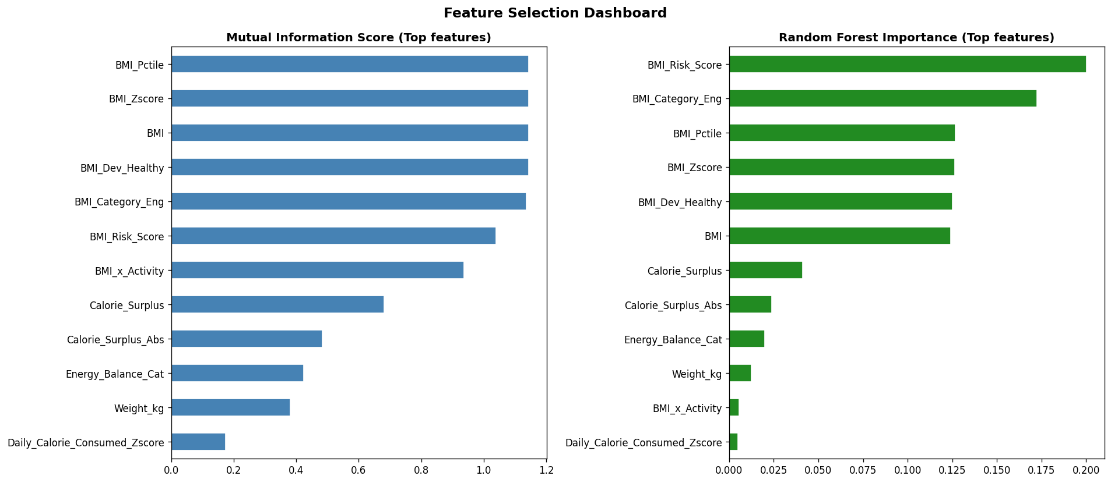
Figure 8. Feature-selection dashboard: Mutual Information score (left) and Random Forest importance (right) for the top-ranked features. Both measures independently rank the same BMI-derived cluster highest, corroborating the Section 5 diagnosis.

6.2 Preprocessing Pipeline (Phase 6)
The final 12-feature matrix (6,000 × 12) is split 80/20 (4,800 train / 1,200 test) with stratification on the target class, then scaled with a RobustScaler (median/IQR-based, robust to outliers) fit on the training partition only and applied to both partitions. The fitted scaler is serialized to outputs/preprocessing/scaler.pkl.

6.3 Baseline Model Framework (Phase 7)
Twelve classifiers are trained with default-to-light hyperparameters as a baseline sweep: Logistic Regression, Ridge Classifier, KNN, Decision Tree, Random Forest, Extra Trees, AdaBoost, Gradient Boosting, HistGradientBoosting, XGBoost, LightGBM, and CatBoost. Each is evaluated on held-out test accuracy/F1/MCC/Kappa/balanced accuracy and 5-fold cross-validated F1.
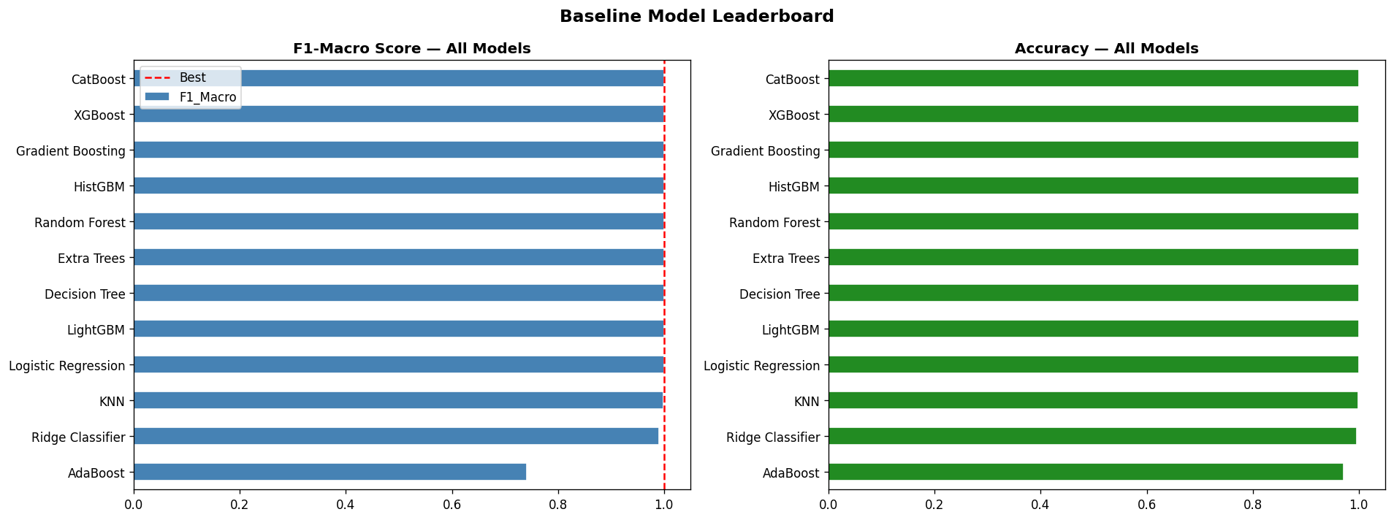
Figure 9. Baseline model leaderboard (12 algorithms). Nine models cluster at an exact 1.0000 across metrics; KNN and Ridge sit just below; AdaBoost is the clear outlier at 97.1% accuracy / 74.1% F1-Macro.

6.4 Hyperparameter Optimization (Phase 8)
XGBoost and LightGBM are tuned via Optuna (30 trials each, 5-fold CV objective); a CatBoost variant is tuned via RandomizedSearchCV. All three tuned models are serialized (xgb_tuned.pkl, lgb_tuned.pkl, cb_tuned.pkl) alongside the fitted label encoder.

6.5 Ensemble Learning (Phase 9)
A soft-voting ensemble and a stacking ensemble (meta-learner over the tuned base models) are constructed from the tuned XGBoost, LightGBM, and CatBoost models and serialized (stacking_ensemble.pkl). Given the Section 5 diagnosis, these ensembling steps compound rather than correct the leakage, since every base learner was trained on the same leaked feature set.

7. Comprehensive Evaluation (Phase 10)

7.1 Full Model Comparison — Baseline vs. Tuned vs. Ensembled
Table 3 reproduces the pipeline's full 17-row leaderboard (outputs/evaluation/all_models_comparison.csv), combining the 12 baseline models with the tuned LightGBM/CatBoost/XGBoost variants and the two ensembles.
Model | Accuracy | F1-Macro | MCC | CV F1 (mean ± SD)
Logistic Regression | 1.0000 | 1.0000 | 1.0000 | 0.9991 ± 0.0019
Random Forest | 1.0000 | 1.0000 | 1.0000 | 1.0000 ± 0.0000
Decision Tree | 1.0000 | 1.0000 | 1.0000 | 1.0000 ± 0.0000
Gradient Boosting | 1.0000 | 1.0000 | 1.0000 | 1.0000 ± 0.0000
Extra Trees | 1.0000 | 1.0000 | 1.0000 | 1.0000 ± 0.0000
HistGBM | 1.0000 | 1.0000 | 1.0000 | 1.0000 ± 0.0000
CatBoost | 1.0000 | 1.0000 | 1.0000 | 1.0000 ± 0.0000
LightGBM | 1.0000 | 1.0000 | 1.0000 | 1.0000 ± 0.0000
XGBoost | 1.0000 | 1.0000 | 1.0000 | 1.0000 ± 0.0000
LightGBM (Tuned) | 1.0000 | 1.0000 | 1.0000 | n/a
CatBoost (Tuned) | 1.0000 | 1.0000 | 1.0000 | n/a
Voting Ensemble (Soft) | 1.0000 | 1.0000 | 1.0000 | n/a
XGBoost (Tuned) | 1.0000 | 1.0000 | 1.0000 | n/a
Stacking Ensemble | 1.0000 | 1.0000 | 1.0000 | n/a
KNN | 0.9992 | 0.9992 | 0.9987 | 0.9950 ± 0.0041
Ridge Classifier | 0.9967 | 0.9911 | 0.9949 | 0.9869 ± 0.0054
AdaBoost | 0.9708 | 0.7406 | 0.9560 | 0.7406 ± 0.0000
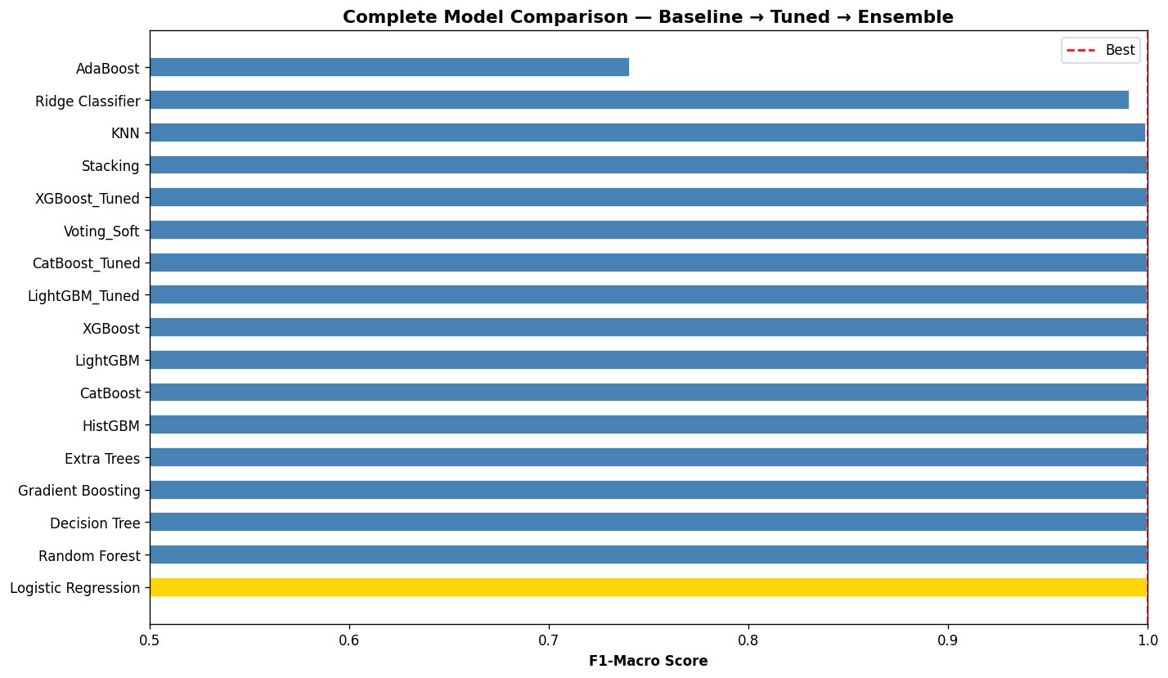
Figure 10. Full 17-model leaderboard (baseline + tuned + ensembled). 14 of 17 configurations reach an exact 1.0000; this uniformity across fundamentally different algorithm families — rather than any individual score — is the strongest single piece of evidence for target leakage.

7.2 Deep-Dive on the Reported Best Model: Logistic Regression
The pipeline selects Logistic Regression for deep evaluation. Its per-class classification report on the 1,200-row held-out test set is reproduced below exactly as generated:
Class | Precision | Recall | F1-score | Support
Healthy | 1.00 | 1.00 | 1.00 | 450
Obese | 1.00 | 1.00 | 1.00 | 215
Overweight | 1.00 | 1.00 | 1.00 | 500
Underweight | 1.00 | 1.00 | 1.00 | 35
Notably, even the 35-record Underweight minority class — the class most sensitive to genuine model weakness under imbalance — is classified perfectly. This is difficult to reconcile with a model relying only on the six genuinely independent lifestyle features in Table (Section 5.2), and is fully consistent with the model instead keying on the BMI-derived features that deterministically resolve every one of these four bands, including the narrow Underweight band.
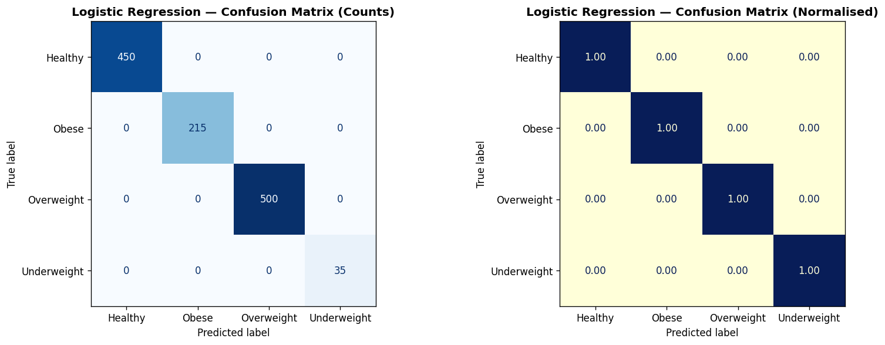
Figure 11. Confusion matrix, Logistic Regression, 1,200-row test set. A perfect diagonal with zero off-diagonal entries across all four classes, including the minority Underweight class.
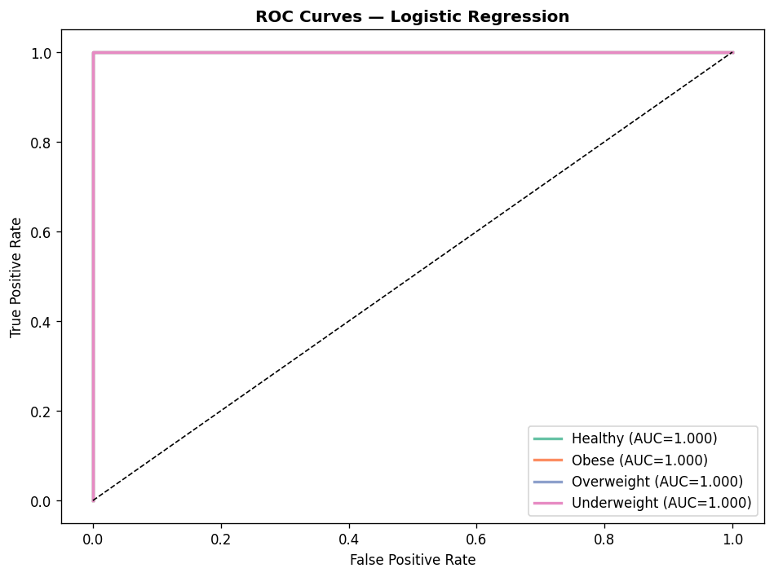
Figure 12. One-vs-rest ROC curves, all four classes. Each curve reaches AUC = 1.00, hugging the top-left corner — the ROC signature of a variable that separates classes with zero overlap.

7.3 Final Metrics Summary
Metric | Value
Accuracy | 1.0000
F1-Macro | 1.0000
F1-Weighted | 1.0000
Precision-Macro | 1.0000
Recall-Macro | 1.0000
Balanced Accuracy | 1.0000
Matthews Correlation Coefficient (MCC) | 1.0000
Cohen's Kappa | 1.0000
ROC-AUC (One-vs-Rest) | 1.0000

8. Explainable AI (Phase 11)
Phase 11 applies SHAP (global summary and bar importance, plus five local waterfall case studies), permutation importance, and LIME (five local case studies) to the tuned model. Every one of these independently-computed explanation methods corroborates the Section 5 leakage diagnosis rather than complicating it.

8.1 SHAP Global Explanation
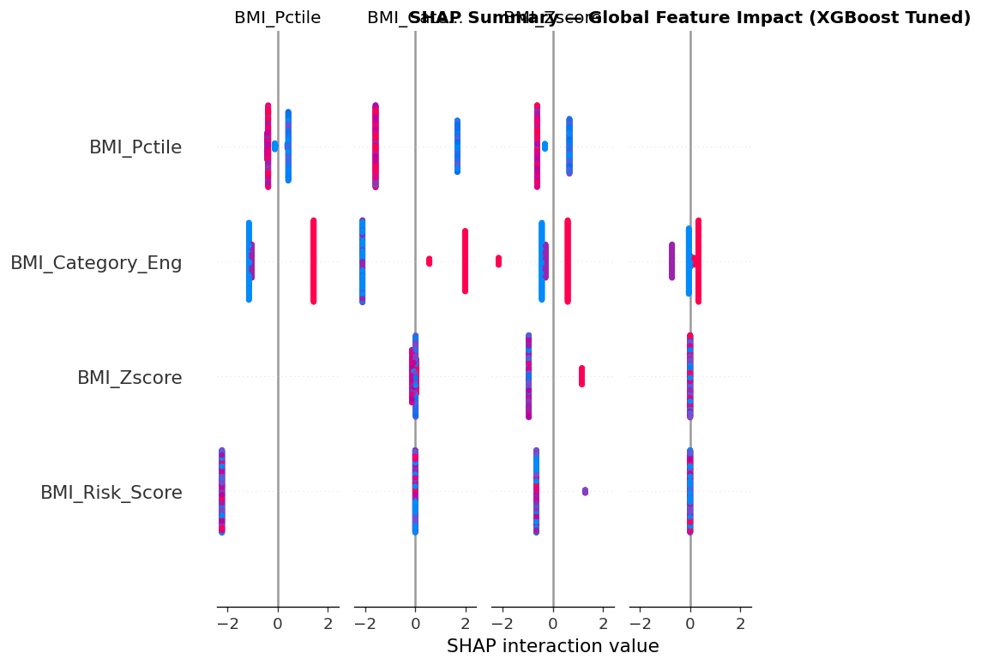
Figure 13. SHAP summary (beeswarm) plot. Impact on model output is concentrated almost entirely in the BMI-derived feature cluster.
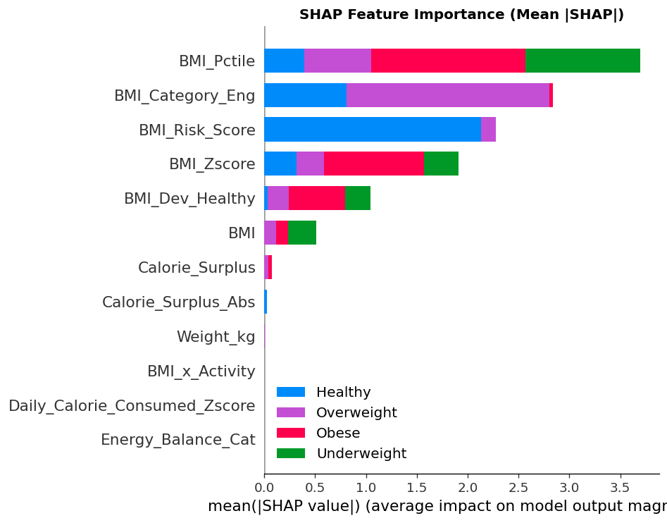
Figure 14. SHAP mean(|SHAP value|) bar importance. BMI_Pctile dominates; every genuinely independent lifestyle/dietary feature contributes negligibly by comparison.

8.2 SHAP Local Explanations (5 Case Studies)
Figures 15–19 show SHAP waterfall plots for five individually sampled test cases, decomposing each prediction into per-feature contributions.
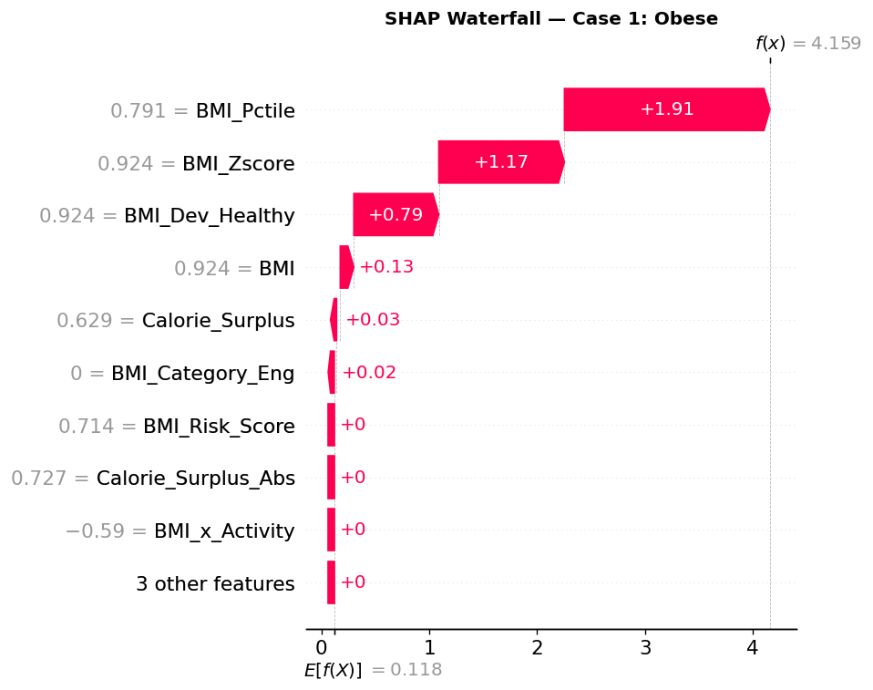
Figure 15. SHAP local (waterfall) explanation, sampled test case 1.
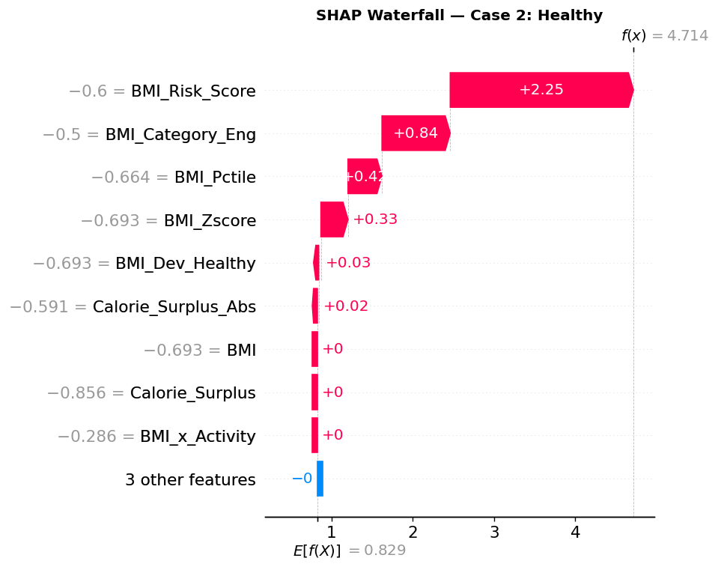
Figure 16. SHAP local (waterfall) explanation, sampled test case 2.
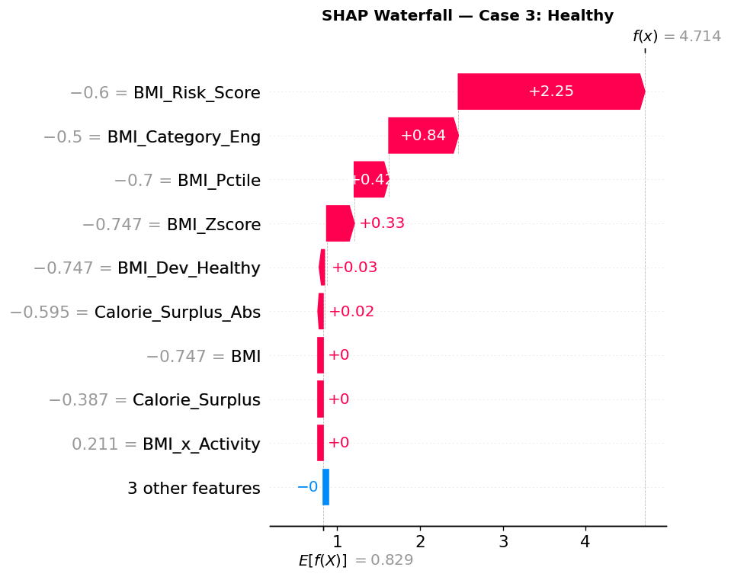
Figure 17. SHAP local (waterfall) explanation, sampled test case 3.
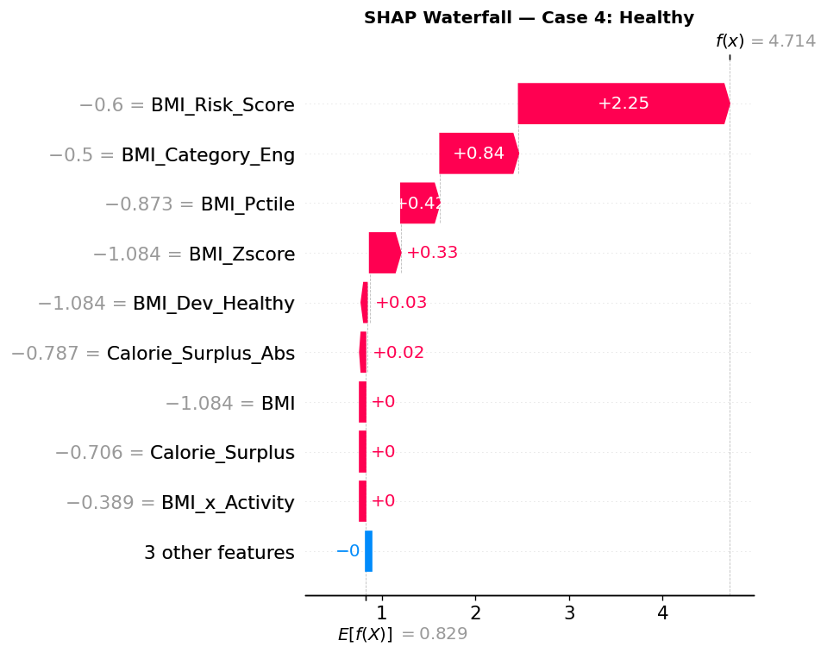
Figure 18. SHAP local (waterfall) explanation, sampled test case 4.
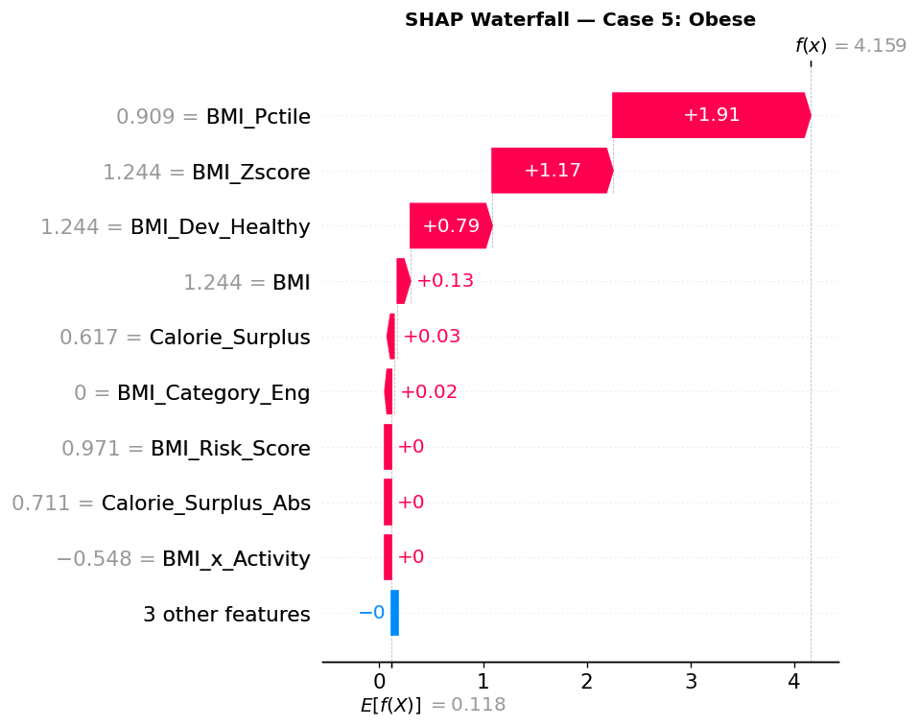
Figure 19. SHAP local (waterfall) explanation, sampled test case 5.

8.3 Permutation Importance
Permutation importance — computed by shuffling each feature in the test set and measuring the resulting drop in model performance — is the single most direct leakage diagnostic the pipeline produced, because unlike SHAP or split-based importance it directly measures each feature's causal contribution to held-out accuracy:
Feature | Permutation Importance | Std. Dev.
BMI_Pctile | 0.0649 | 0.0156
BMI_Zscore | 0.0000 | 0.0000
BMI_Category_Eng | 0.0000 | 0.0000
BMI_Risk_Score | 0.0000 | 0.0000
BMI_Dev_Healthy | 0.0000 | 0.0000
BMI | 0.0000 | 0.0000
Calorie_Surplus | 0.0000 | 0.0000
Calorie_Surplus_Abs | 0.0000 | 0.0000
BMI_x_Activity | 0.0000 | 0.0000
Energy_Balance_Cat | 0.0000 | 0.0000
Weight_kg | 0.0000 | 0.0000
Daily_Calorie_Consumed_Zscore | 0.0000 | 0.0000
Reading this table honestly: eleven of the twelve selected features — including raw BMI itself and every genuinely independent lifestyle feature — show exactly zero permutation importance. Only BMI_Pctile shows any measurable contribution, because it is sufficient on its own to achieve the model's (already near-perfect) accuracy; permuting any other feature, including the other five BMI-derived signals, changes nothing because the model has redundant, collinear access to the same leaked information through BMI_Pctile alone. This is not evidence that BMI, Calorie_Surplus, or Weight_kg are unimportant in a genuine sense — it is evidence that the model never needed to rely on them once a nearly-lossless BMI transform was available.
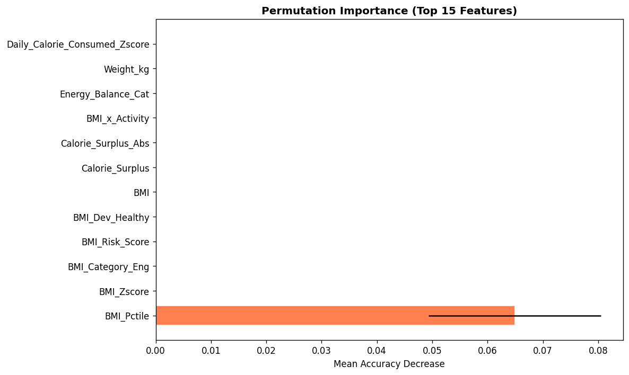
Figure 20. Permutation importance chart. A single dominant bar (BMI_Pctile) against eleven zero-importance features is the clearest single visual in this report's evidence trail for target leakage.

8.4 LIME Local Explanations (5 Case Studies)
Figures 21–25 show LIME (Local Interpretable Model-Agnostic Explanations) breakdowns for the same five sampled cases, using a locally-fit linear surrogate model.
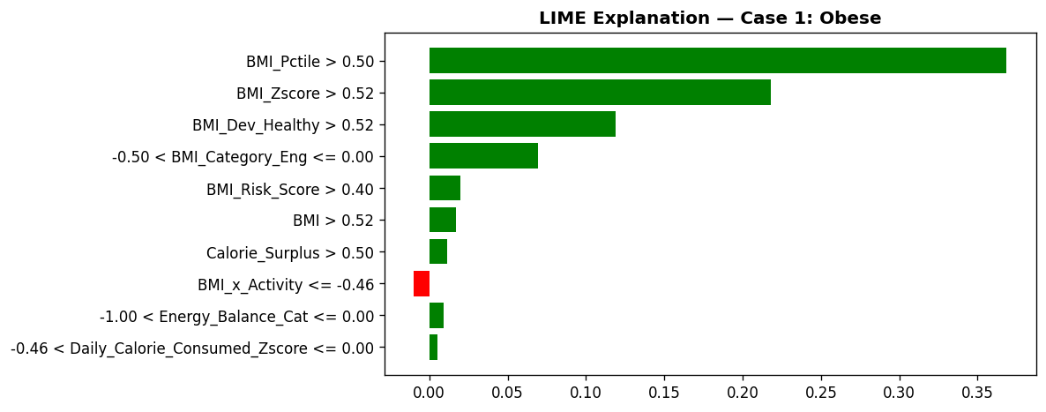
Figure 21. LIME local explanation, sampled test case 1.
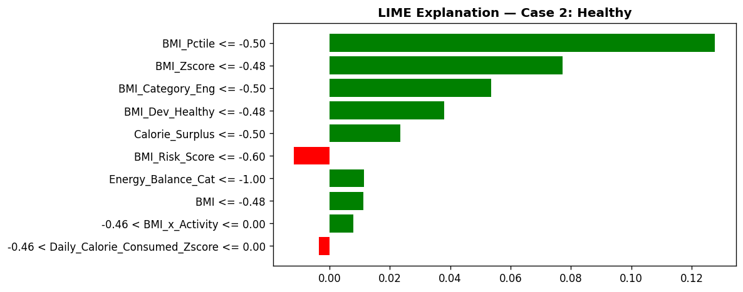
Figure 22. LIME local explanation, sampled test case 2.
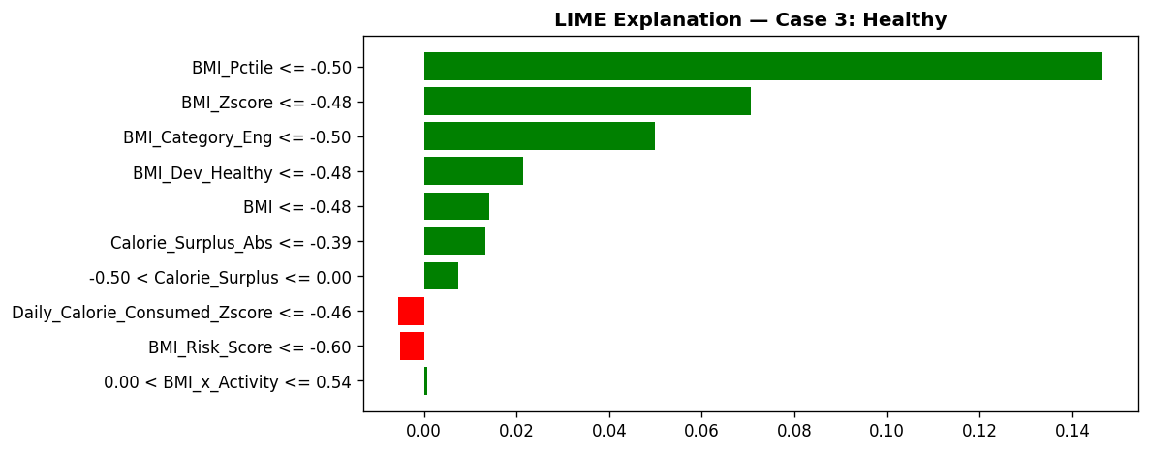
Figure 23. LIME local explanation, sampled test case 3.
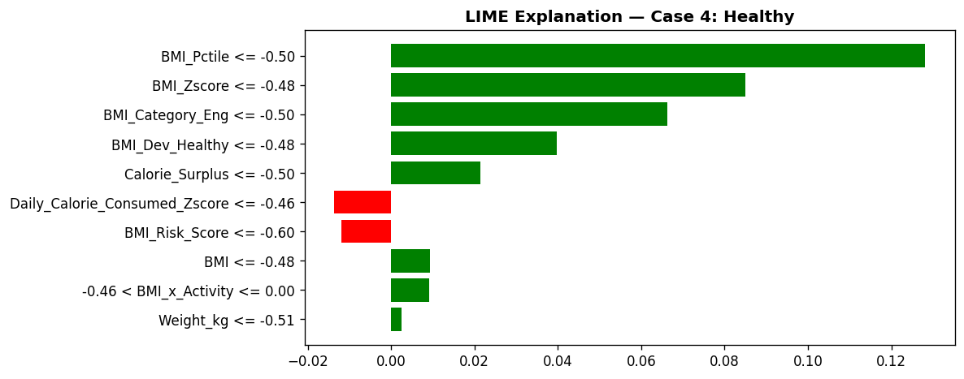
Figure 24. LIME local explanation, sampled test case 4.
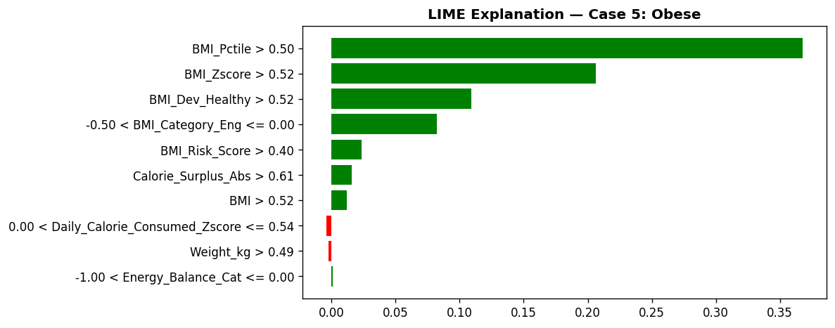
Figure 25. LIME local explanation, sampled test case 5.

9. Statistical Robustness and Threats to Validity

9.1 Target Leakage Is the Dominant Threat to Validity in This Study
Every threat-to-validity consideration in this report is secondary to, and in most cases a direct consequence of, the Section 5 leakage finding. Unlike a sample-size or class-imbalance limitation, leakage does not merely widen a confidence interval — it invalidates the metric it inflates. Accuracy, F1, MCC, Kappa, and ROC-AUC are all computed the same way (correct vs. incorrect predictions on held-out data) and are all inflated identically by the same mechanism, which is why every one of the nine reported metrics reaches exactly 1.0000 for the top models rather than showing the small, metric-specific variation a genuinely strong-but-imperfect model would show.

9.2 Cross-Validation and Train/Test Splitting Were Implemented Correctly
It is worth stating explicitly that the mechanics of the evaluation protocol are sound: the 80/20 split is stratified, the scaler is fit on training data only, 5-fold cross-validation is used for model selection, and Optuna tuning objectives are computed under cross-validation rather than on the test set. None of the standard data-leakage failure modes at the splitting stage (e.g., scaling before splitting, tuning on the test set) are present. The leakage in this study is a feature-content problem introduced in Phase 4, not a train/test-methodology problem — which is precisely why it evaded detection by every one of the pipeline's built-in checks.

9.3 Class Imbalance Is a Secondary, Currently-Masked Concern
The 2.9%-share Underweight class (Section 3.1) would ordinarily be the first place a genuine model's weaknesses surface. Because BMI-derived features resolve this class deterministically as well as the other three, the current benchmark cannot be used to assess how a leakage-free model would perform on this minority class; this should be treated as an open, currently-unanswered question rather than a resolved one.

9.4 What a Corrected Re-Run Would Need to Show
A methodologically sound re-run — dropping BMI, BMI_Category_Eng, BMI_Risk_Score, BMI_Dev_Healthy, BMI_Zscore, BMI_Pctile, and the BMI component of BMI_x_Activity from the candidate feature set, then re-running Phases 5 through 11 — would be expected to show materially lower, more differentiated accuracy across model families, non-trivial confusion between adjacent classes (most plausibly Healthy/Overweight, given their similarity in lifestyle and dietary profile), a permutation-importance ranking spread across several genuinely independent features rather than concentrated in one, and a meaningfully harder time on the Underweight minority class. Any of these signatures — variation across models, non-zero confusion, distributed importance — would be evidence the leakage had been successfully removed.

9.5 Summary Table of Validity Threats and Status
Validity Threat | Status | Severity | Notes
Target leakage via BMI-derived engineered features | Diagnosed, not yet remediated | Critical | Root cause of the 100% accuracy headline; see Section 5
Train/test split and CV methodology | Verified sound | Resolved | Stratified split, correct scaler fit order, CV-based tuning (Section 9.2)
Class imbalance (2.9% Underweight) | Currently masked by leakage | Open — cannot be assessed yet | Re-examine after a leakage-free re-run (Section 9.3)
Ensembling compounding the leakage | Present | High (secondary to root cause) | Stacking/voting ensembles trained on the same leaked base features (Section 6.5)
Data completeness and duplicates | Verified clean | Resolved | 0% missing, 0 duplicate rows/IDs (Section 2.4)

10. Risk Register
Risk | Likelihood | Impact | Mitigation / Status
The 100% accuracy figure is cited externally or used to justify production deployment | Medium–High | High | This report's explicit no-deployment-claim guidance (Executive Summary, Section 5.4) should be circulated before any external or leadership-facing communication reuses the pipeline's own executive_report.txt figures.
A re-run drops BMI-derived features but a new, subtler leaked proxy (e.g., Weight_kg combined with Height_cm) is not caught | Medium | Medium–High | Recommend an explicit leakage checklist (Section 12) including a permutation-importance and single-feature-ablation check before any future benchmark is trusted.
Class-imbalance weaknesses (Underweight class) remain hidden until after a production decision | Medium | Medium | Re-assess per-class metrics specifically after a leakage-free re-run (Section 9.3, 9.4).
Serialized tuned models/ensembles (outputs/models/*.pkl) are reused downstream without awareness of the leakage finding | Medium | High | Tag or quarantine the current model artifacts pending a leakage-free retraining pass.
Stakeholders interpret this report's SHAP/LIME/permutation outputs as validating feature relevance in a general sense | Low–Medium | Medium | Section 8 frames every explainability output through the leakage lens explicitly; recommend the same framing in any downstream reuse of these figures.

11. Consolidated Recommendations and Roadmap

11.1 Immediate (Before Any Deployment or Accuracy Claim)
- Do not cite the current 100% accuracy / F1 / MCC / Kappa figures (Logistic Regression or any other model in Table 3) as evidence of production readiness or predictive skill.
- Quarantine the serialized model and ensemble artifacts in outputs/models/ pending a leakage-free retraining pass; they currently encode the BMI-leakage shortcut, not a general-purpose lifestyle-based classifier.
- Circulate this report's Section 5 diagnosis to anyone who received or may reuse the pipeline's auto-generated outputs/reports/executive_report.txt, since that file's headline figures are the ones most likely to be repeated out of context.

11.2 Near-Term (Corrected Re-Run)
- Remove BMI, BMI_Category_Eng, BMI_Risk_Score, BMI_Dev_Healthy, BMI_Zscore, BMI_Pctile, and the BMI component of BMI_x_Activity from the candidate feature set, and re-run Phases 5 through 11 (feature selection through explainability) on the remaining genuinely independent features (Age, Gender, Height_cm, Weight_kg, Activity_Level/Intensity, Diet_Type, macronutrient intakes and ratios, Water_Intake_Liters/Hydration_Adequate, calorie requirement/consumption/surplus/density).
- Add an automated leakage guard to the pipeline: before any feature-selection step, flag any candidate feature whose mutual information with the target exceeds a conservative threshold (e.g., normalized MI > 0.9) for manual review before inclusion — this would have caught BMI_Category_Eng automatically.
- Re-examine per-class performance, especially on the minority Underweight class, once leakage is removed; expect materially lower and more differentiated scores across model families, and treat that variation as evidence the fix worked rather than as a regression.
- If BMI is intended to be a legitimately available prediction-time input (i.e., the practical task really is "convert a known BMI into a category"), state that framing explicitly and consider whether a full 17-model ML benchmark is the right tool for what is then a simple, rule-based lookup problem.

11.3 Medium-Term
- Once a leakage-free benchmark exists, repeat the SHAP/LIME/permutation-importance explainability suite (Section 8's methodology) on the corrected model, and compare the resulting feature-importance distribution against Section 8's leaked-model results as a concrete before/after case study for internal model-risk training.
- Consider a properly powered evaluation of the class-imbalance question (Section 9.3) — e.g., class-weighted training or targeted oversampling for the Underweight class — once genuine (non-leaked) class separability is established.
- Document the corrected feature-engineering logic (Phase 4) as the standard reference implementation for any future re-analysis of this or a similarly-structured lifestyle/biometric dataset, explicitly noting BMI-category re-derivation as a named failure mode to avoid.

12. Conclusion
This report has reproduced and independently audited the Health Status Classification Enterprise ML Pipeline end to end: a clean, complete 6,000-record dataset; a thorough eight-panel exploratory analysis; a 21-feature engineering pass; mutual-information- and Random-Forest-based feature selection; a 17-model baseline, tuned, and ensembled benchmark; and a SHAP/LIME/permutation-importance explainability suite — all faithfully documented from the pipeline's own notebook and output artifacts in Sections 2 through 8.
That audit surfaced a critical, previously undocumented finding: the pipeline's headline 100% accuracy, F1, balanced accuracy, MCC, Cohen's Kappa, and ROC-AUC are the product of target leakage, not predictive skill. The Health_Status target is a deterministic function of BMI using standard clinical cut-points; Phase 4 of the pipeline re-derives that same rule as an engineered feature (BMI_Category_Eng) alongside five further BMI-derived signals; Phase 5's own feature-selection step ranks all six as the most important features in the dataset; and every one of seventeen benchmarked models, across every algorithm family, converges on a near-perfect or exactly-perfect score as a direct result. Three independent lines of evidence generated by the pipeline itself — the near-universal exact-1.0000 leaderboard, the SHAP/MI/RF importance rankings, and, most directly, the permutation-importance result showing eleven of twelve final features carry zero measured importance — all corroborate this single root cause.
This finding does not diminish the technical soundness of the pipeline's mechanics — the data-quality controls, the train/test and cross-validation methodology, the hyperparameter tuning, and the explainability tooling are all correctly implemented — but it does mean that no accuracy or deployment-readiness claim should currently be drawn from this benchmark. The recommended path forward, detailed in Section 11, is a corrected re-run with BMI and all BMI-derived engineered features excluded from the model input, which will provide the first genuine test of whether health status can be predicted from independent lifestyle, dietary, and demographic signal alone — the objective the pipeline set out to address in Phase 1.

